E. Necklace Assembly
time limit per test
2 seconds
memory limit per test
256 megabytes
input
standard input
output
standard output
The store sells nn beads. The color of each bead is described by a lowercase letter of the English alphabet ("a"–"z"). You want to buy some beads to assemble a necklace from them.
A necklace is a set of beads connected in a circle.
For example, if the store sells beads "a", "b", "c", "a", "c", "c", then you can assemble the following necklaces (these are not all possible options):
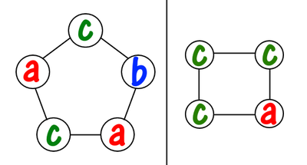
And the following necklaces cannot be assembled from beads sold in the store:
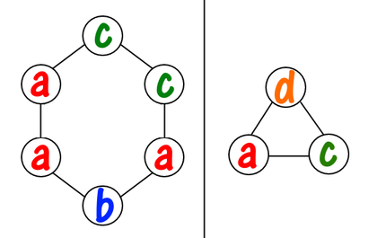The first necklace cannot be assembled because it has three beads "a" (of the two available). The second necklace cannot be assembled because it contains a bead "d", which is not sold in the store.
We call a necklace kk-beautiful if, when it is turned clockwise by kk beads, the necklace remains unchanged. For example, here is a sequence of three turns of a necklace.
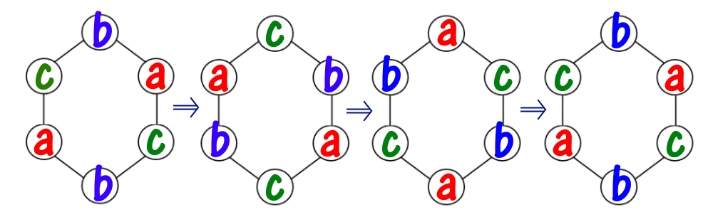
As you can see, this necklace is, for example, 33-beautiful, 66-beautiful, 99-beautiful, and so on, but it is not 11-beautiful or 22-beautiful.
In particular, a necklace of length 11 is kk-beautiful for any integer kk. A necklace that consists of beads of the same color is also beautiful for any kk.
You are given the integers nn and kk, and also the string ss containing nn lowercase letters of the English alphabet — each letter defines a bead in the store. You can buy any subset of beads and connect them in any order. Find the maximum length of a kk-beautiful necklace you can assemble.
Input
The first line contains a single integer tt (1≤t≤1001≤t≤100) — the number of test cases in the test. Then tt test cases follow.
The first line of each test case contains two integers nn and kk (1≤n,k≤20001≤n,k≤2000).
The second line of each test case contains the string ss containing nn lowercase English letters — the beads in the store.
It is guaranteed that the sum of nn for all test cases does not exceed 20002000.
Output
Output tt answers to the test cases. Each answer is a positive integer — the maximum length of the kk-beautiful necklace you can assemble.
Example
input
Copy
6
6 3
abcbac
3 6
aaa
7 1000
abczgyo
5 4
ababa
20 10
aaebdbabdbbddaadaadc
20 5
ecbedececacbcbccbdec
output
Copy
6
3
5
4
15
10
Note
The first test case is explained in the statement.
In the second test case, a 66-beautiful necklace can be assembled from all the letters.
In the third test case, a 10001000-beautiful necklace can be assembled, for example, from beads "abzyo".

我们暂时把这种性质成为k循环。假如我们一个环是k循环的，那么肯定也是nk循环的，所以我们枚举k的因子i，然后枚举倍数j，表示这个环由j组一样的长度为i的串组成，那么这个大串就是i循环，同时也就是k循环，所以最后维护最大值就行了。
额。。。我居然忘记了还可以aabbcc搞成一组循环。。我sb
唉，，希望你多想一会啦。

#include<bits/stdc++.h>
#define ll long long
using namespace std;
map<char,int> vis;
int tot[3000];
int hehe[3000];
int cmp(int a,int b)
{
return a>b;
}
int main()
{
int t;
scanf("%d",&t);
while(t--)
{ vis.clear();
memset(tot,0,sizeof tot);
int n,k;
scanf("%d %d",&n,&k);
int cnt=0;
string a;
cin>>a;
for(int i=0;i<a.length();i++)
{
if(!vis[a[i]]) {vis[a[i]]=1; cnt++;}
tot[a[i]-'a']++;
}

int ans=1;
for(int i=1;i<=k;i++)
{
if(k%i==0)
{
for(int j=1;j*i<=n;j++)
{ int sum=0;
for(int kk=0;kk<26;kk++)
{ //if(i==5&&j==3) cout<<tot[kk]<<" "<<tot[kk]/j<<" "<<"\n";
sum+=tot[kk]/j;
}
if(sum>=i) {ans=max(ans,i*j);}
}
}
}
printf("%d\n",ans);
}
return 0;
}

